Ordering Method Configuration

There are four ordering systems available to use within ProScript Connect, each of which provide a different method of managing your ordering processes and stock management. This article will provide you with an explanation of the available methods, along with the key *Ordering* and *Stock*configurations to consider when setting your ordering method.

Replace

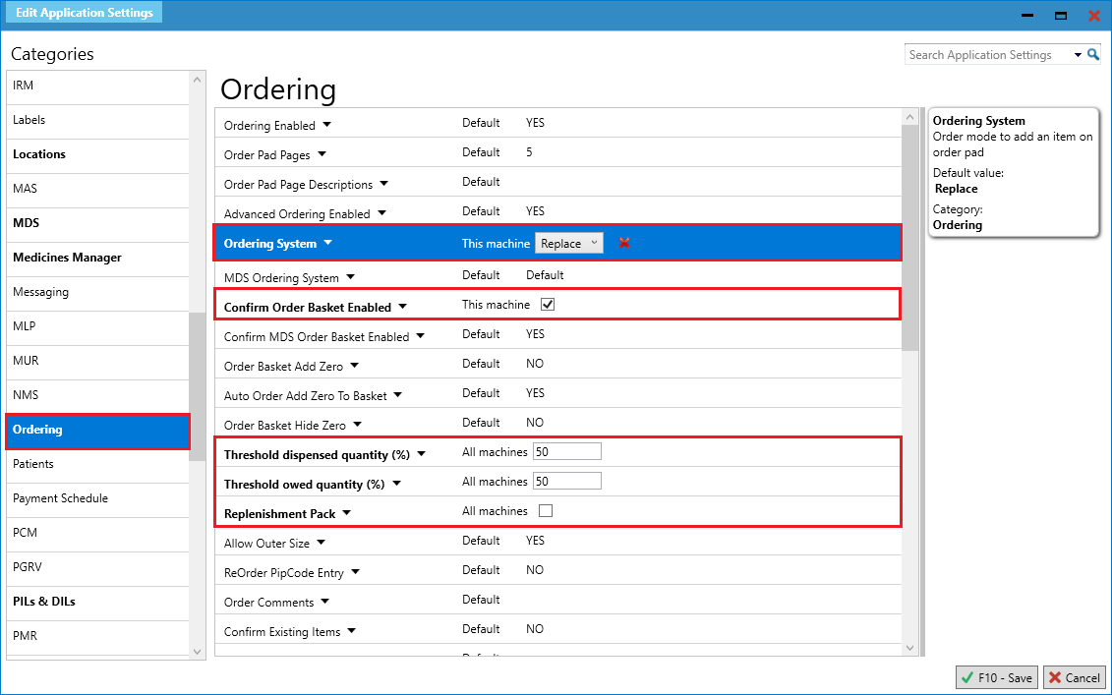

|  |  |  |  |
| --- | --- | --- | --- |
| **Ordering Method** | **Explanation** | **Works with (application settings)** | **Considerations (application settings)** |
| Replace | A one-for-one ordering method. | ***Confirm Order Basket Enabled (Ordering)*** Make the *Replace* order method work more efficiently by enabling the Reorder Basket to appear after dispensing events. | ***Replenishment Pack (Ordering)***  Enabling this setting will build up the unit quantity until it reaches a full pack to be ordered.  C:\Users\POONID\AppData\Local\Microsoft\Windows\Temporary Internet Files\Content.IE5\9XKYY7UK\Birne[1].pngIf this is enabled, any value entered in the *Threshold Dispensed Quantity (%)* setting will be ignored. |
| ***Threshold Dispensed Quantity (%) (Ordering)*** Once a dispensing event has taken place, the system will trigger an order for a full pack where the dispensed quantity is equal to or more than the pack % threshold specified. |
| ***Threshold Owed Quantity (%) (Ordering)*** Once an owing has been created for a patient, the system will trigger an order for a full pack where the owing quantity is equal to or more than the pack % threshold specified. |

Reminder

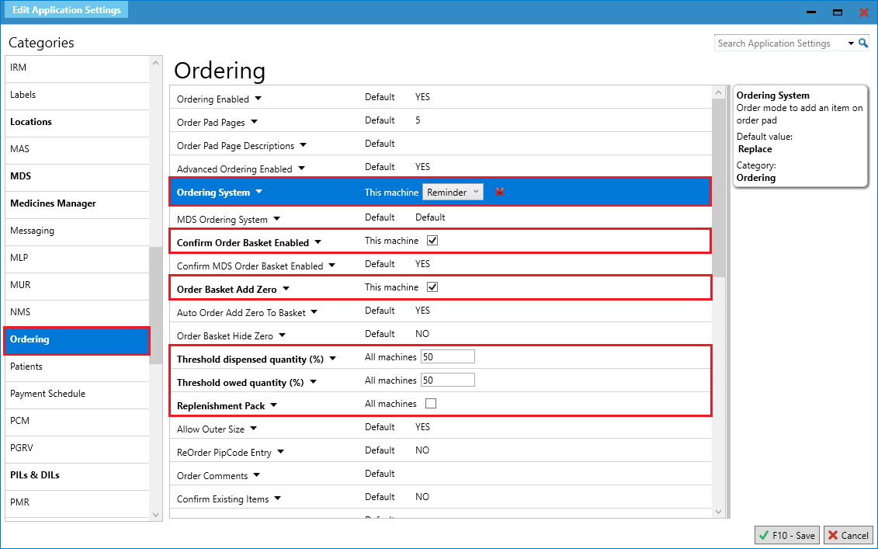

|  |  |  |  |
| --- | --- | --- | --- |
| **Ordering Method** | **Explanation** | **Works with (application settings)** | **Considerations (application settings)** |
| Reminder | Once ordering is triggered as configured, the item will be added to the *Order Pad* with zero quantity for you to complete manually. | ***Confirm Order Basket Enabled (Ordering)*** Make the *Reminder* order method work more efficiently by enabling the Reorder Basket to appear after dispensing events. | C:\Users\POONID\AppData\Local\Microsoft\Windows\Temporary Internet Files\Content.IE5\9XKYY7UK\Birne[1].png***Order Basket Add Zero (Ordering)*** Allows zero quantity items to be added to the *Order Pad* when accepting items on the Reorder Basket.  This setting must be enabled for the *Reminder* ordering method to work effectively. |
| ***Threshold Dispensed Quantity (%) (Ordering)*** Once a dispensing event has taken place, the system will trigger an order where the dispensed quantity is equal to or more than the pack % threshold specified. | ***Replenishment Pack (Ordering)***  Enabling this setting will build up the unit quantity until it reaches a full pack to be ordered.  C:\Users\POONID\AppData\Local\Microsoft\Windows\Temporary Internet Files\Content.IE5\9XKYY7UK\Birne[1].pngIf this is enabled, any value entered in the *Threshold Dispensed Quantity (%)* setting will be ignored. |
| ***Threshold Owed Quantity (%) (Ordering)*** Once an owing has been created for a patient, the system will trigger an order where the owing quantity is equal to or more than the pack % threshold specified. |

Auto & Auto Suppress

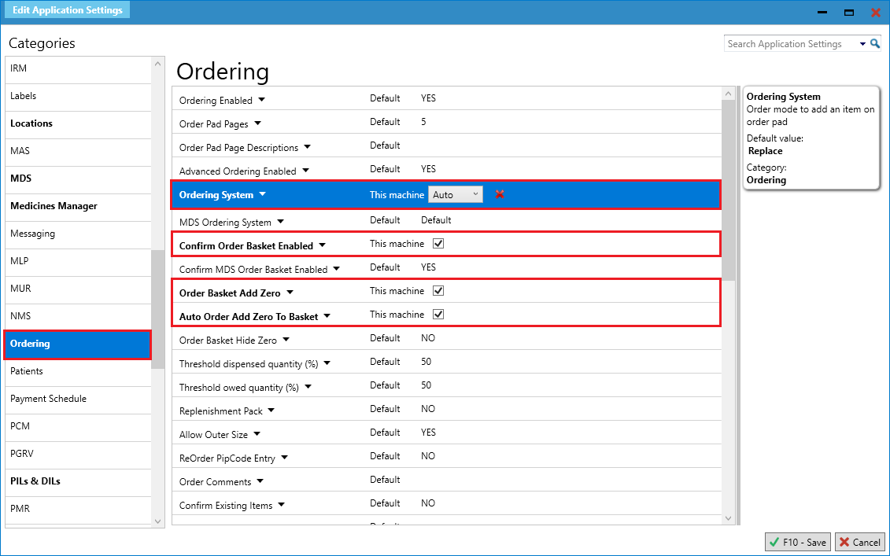

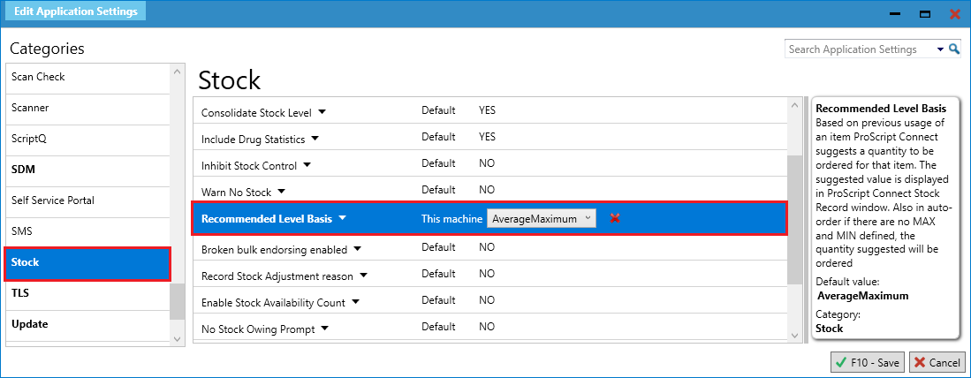

|  |  |  |  |
| --- | --- | --- | --- |
| **Ordering Method** | **Explanation** | **Works with (application settings)** | **Considerations (application settings)** |
| Auto & Auto Suppress | Where the *Auto* ordering mode  is enabled, the system will first calculate the total sum of the values associated to the item’s stock card properties below:   * *Stock Holding* quantity * *On Order Pad* quantity * *Due In* quantity   Once the total sum is calculated, it will then be compared with the item’s stock card (*Recommended Level Basis*) or (*Min/Max* set).  Where the total sum calculated is less than the (*Recommended Level Basis*) or (*Min/Max* set), then the system will determine the actual amount to order.  C:\Users\POONID\AppData\Local\Microsoft\Windows\Temporary Internet Files\Content.IE5\9XKYY7UK\Birne[1].png*Auto Suppress* works in a similar way as *Auto*, however the functionality is only invoked when the Ordering Manager is opened. | ***Recommended Level Basis (Stock)***  Used by the system to determine how many packs will be ordered for an item.   * *AverageMaximum*: A system calculated mean of the item’s maximum dispensed quantity per month over the last 3 months (recommended stock level). This excludes the current month unless there is no data in the previous 3 months, in which case the current month will be used as a gauge.   C:\Users\POONID\AppData\Local\Microsoft\Windows\Temporary Internet Files\Content.IE5\9XKYY7UK\Birne[1].pngThis will be overridden where the *Min* or Max values *(Up To/Value)* are set at item level.   * *AveragePacks*: This is a placeholder for future stock management enhancements. At the moment, enabling this option will use the *Min*or Max values *(Up To/Value)* set at item level. | ***Confirm Order Basket Enabled (Ordering)***  Make the *Auto Suppress* order method work more efficiently by enabling the Reorder Basket to appear upon opening the Ordering Manager.  C:\Users\POONID\AppData\Local\Microsoft\Windows\Temporary Internet Files\Content.IE5\9XKYY7UK\Birne[1].pngIf this setting is disabled, flash messages will appear to advise how many items have been added to the *Order Pad* upon opening the Ordering Manager. |
| ***Auto Order Add Zero To Basket (Ordering)***  Where the order quantity is calculated as zero, the item will be added to the *Order Pad* with a zero quantity. | ***Order Basket Add Zero (Ordering)***  Allows zero quantity items to be added to the *Order Pad* when accepting items on the Reorder Basket.  C:\Users\POONID\AppData\Local\Microsoft\Windows\Temporary Internet Files\Content.IE5\9XKYY7UK\Birne[1].pngThis setting must be enabled for the *Auto Order Add Zero To Basket*setting to work effectively. |
| ***Confirm Order Basket Enabled (Ordering)***  Make the *Auto*order method work more effectively by enabling the Reorder Basket to appear after dispensing events. | ***Advanced Ordering Enabled (Ordering)***  Enables *Auto* and *Auto Suppress* ordering.  C:\Users\POONID\AppData\Local\Microsoft\Windows\Temporary Internet Files\Content.IE5\9XKYY7UK\Birne[1].pngThis setting must be enabled to use the *Auto* and *Auto Suppress* ordering methods. |

**Revision History**

|  |  |  |  |
| --- | --- | --- | --- |
| Version Number | Date | Revision Details | Author(s) |
| 1.0 | 10 July 2019 |  | Joanne Hibbert-Gorst |
|  |  |  |  |
|  |  |  |  |

**Contact us**

For more information contact:

**Telephone: 0344 209 2601**

Not to be reproduced or copied without the consent of AAH Pharmaceuticals Limited 2019.